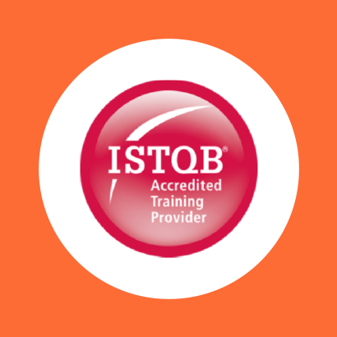

COURSE OUTLINE

Course Name: ISTQB Advanced Technical Test Analyst Module

DURATION | SKILL LEVEL | DELIVERY  METHOD | TRAINING  CREDITS | TECHNOLOGY
3 Day(s) | Advanced | In Class/VILT | N/A | ISTQB

Course Overview
This three-day course is a continuation from the ISTQB Foundation Level Certificate and leads to the ISTQB Advanced Technical Test Analyst certification.

The course focuses specifically on technical test analyst issues such as producing test documentation in relation to technical testing, choosing and applying appropriate specification-based, structure-based, defect based and experience-based test design techniques, and specifying test cases to evaluate software characteristics.

Audience
This three-day course is appropriate for technical testers, developers, performance testers, test automators and anyone wishing to gain the ISTQB Advanced Level Technical Test Analyst qualification

Topics

TEST TECHNIQUES: SPECIFICATION-BASED
Explains and demonstrates how to use and apply the following test design techniques: equivalence partitioning, boundary value analysis, decision tables, and state transition testing.

TEST TECHNIQUES: STRUCTURAL-BASED
Explains and demonstrates how to use and apply the following test design techniques: statement testing, decision testing, condition determination testing, and multiple condition testing.

TEST TECHNIQUES: DEFECT AND EXPERIENCE-BASED
Describes the principles and reasons for defect-based techniques and di_erentiates its use from specification-based and structure-based techniques. Explains, using examples, the importance of defect taxonomies and their uses.

The following defect and experienced-based techniques will be described and used to generate tests: error guessing, exploratory testing, and attacks. Candidates will analyse various systems in order to determine which specification-based and defect-based techniques best fit the application being tested.

STATIC ANALYSIS
Teaches understanding of and di_erentiation between control flow and data flow defects, and how static analysis tools can assist the tester in this task.

DYNAMIC ANALYSIS
Explains dynamic analysis and its importance in determining various memory related defects

TEST OF SOFTWARE CHARACTERISTICS
Testing the system’s functionality is an important aspect for every tester, focusing on what the system does. Another vital area for every tester is to test how well it behaves. Analysis of suitable techniques are provided to
ascertain what characteristics are tested by technical testers. Quality characteristics for technical testers include technical security, reliability, e_ciency, performance, maintainability and portability.

TEST AUTOMATION
Provides valuable insight into the production of keyword-driven scripting for use in test execution tools and how performance tools work. This course provides the tester with information about e_ciency characteristics of the
application. Specific tools will be described that will assist the technical tester.

THE EXAM
This course will provide the candidate with the necessary knowledge and skills to sit the ISTQB Advanced Technical Test Analyst Certificate multiple-choice exam. Candidates will be given the opportunity to sit the examination at the end of the course. Information about the certification can
be found on the International Software Testing Qualifications Board (ISTQB)

Exams and Certifications
No associated Exams. A Certificate of completion is issued at the end of the Course.

Notes and Annotations
Not Any
What is Next
Art of communication

